Healthy Snacks

Although I don’t advocate snacking as a rule, as it’s best to allow a good 5 hours in- between meals to allow the digestive system time to rest. Snacks can be an important part of a healthy diet for some. Eating the right food and snacks at regular intervals (approx. every 2-3 hours) can help to keep energy levels constant, food cravings down and prevents excessive hunger that may lead to overeating. Small, wisely chosen snacks between meals can promote good health and adds pleasure to life.

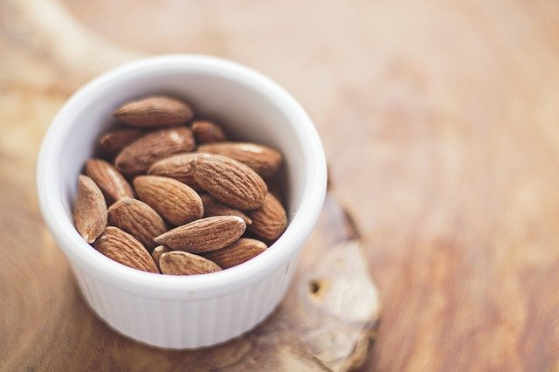
Smart Snacking Strategies
Here are some smart snacking strategies that can help make between-meal eating a nutritious, enjoyable part of your daily routine. If you’d like to master going without snacking I can help you achieve this. I used to be a serial snacker, but now I’m able to go long periods without food, through balancing my blood sugar levels.

- Prepare healthy snacks in advance.
- Keep a variety of ready-to-eat snacks on hand at home, at work or take them out and about with you.
- Snack with variety, balance and moderation in mind. Satisfy cravings with healthier alternatives.
- Snack consciously as snacking absentmindedly, while doing other things, other activities could lead to overeating.
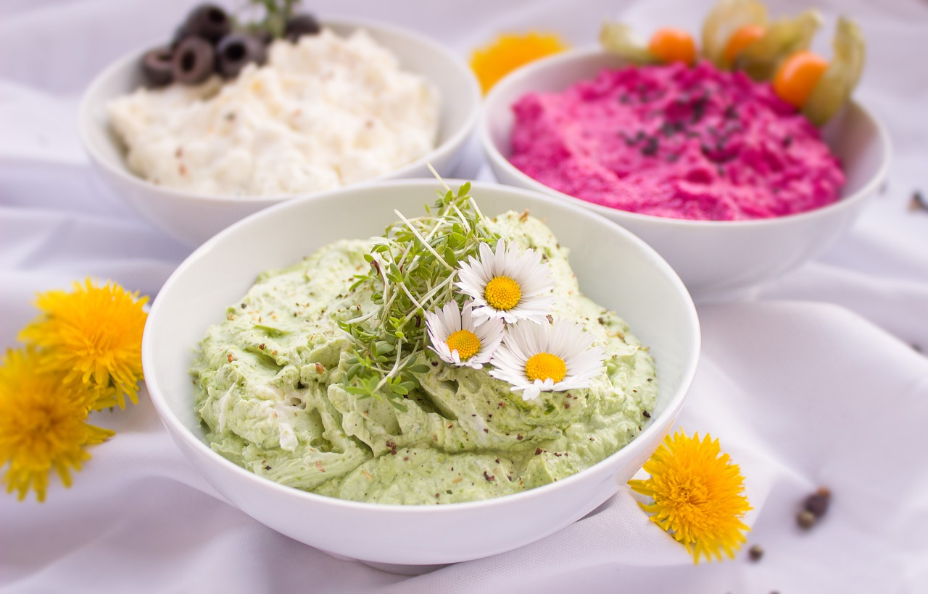
Top Tips for Choosing Snacks
- Choose protein and carbohydrate combination snacks.
- Choose fibre rich and low sodium snacks.
- Choose food rich in good fats (ie) Essential fatty acids Omega 3&6. Oily fish, nuts such as walnuts which are higher in omega 3 than other nuts and flaxseeds, also called linseeds.
- Avoid processed or pre-packed snacks and meals.
- Avoid refined sugars and artificial sweeteners.
- Snack on foods that complement your meals and add variety to your diet.

Easy Snacks Ideas

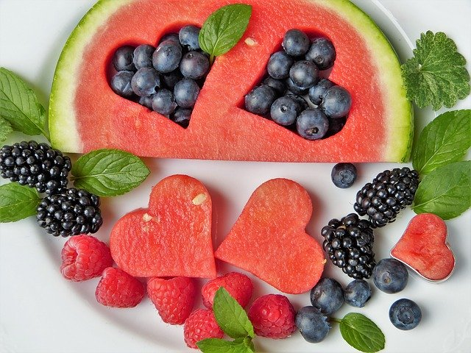
- A piece of fruit with 5 or 6 raw nuts (Unroasted and unsalted).
- 1 piece of fruit with a handful of mixed seeds (sesame, pumpkin and sunflower).
- 2 oatcakes, with a thin scraping of nut butter, such as the Meridian brand.
- 2 oatcakes, or rice cakes with a choice of topping: cottage cheese; oily fish pate; hard-boiled egg with herbs, hummus, avocado, or guacamole.
- Raw vegetable crudités with your choice of healthy dip.
- Fresh veg/fruit smoothie (with/without nuts) or a vegetable Juice.
- Scrambled egg on 1 slice of home made gluten free toasted soda bread.
- Avocado on 1 slice of home made gluten free toasted soda bread.
- Small pack of lentils, or beans with salad. Try Merchant Gourmet for convenience.
- Small pack of salmon on quinoa with salad.
- Crab or other seafood sticks.
- Cereal bars; compare labels to choose one that is lower in fat, sugar and salt.
- 1 small bowl of porridge topped with fresh fruit, nuts and seeds with organic almond, oat or coconut milk.

